Quiz 2

Saddam Abbasi

10/20/2021

## R Markdown

This os the document for Quiz 2 in which I will analysze the Iris dataset i nR. The details of the *IRIS* dataset can be found at <https://archive.ics.uci.edu/ml/datasets/iris>.

summary(iris)

## Sepal.Length Sepal.Width Petal.Length Petal.Width   
## Min. :4.300 Min. :2.000 Min. :1.000 Min. :0.100   
## 1st Qu.:5.100 1st Qu.:2.800 1st Qu.:1.600 1st Qu.:0.300   
## Median :5.800 Median :3.000 Median :4.350 Median :1.300   
## Mean :5.843 Mean :3.057 Mean :3.758 Mean :1.199   
## 3rd Qu.:6.400 3rd Qu.:3.300 3rd Qu.:5.100 3rd Qu.:1.800   
## Max. :7.900 Max. :4.400 Max. :6.900 Max. :2.500   
## Species   
## setosa :50   
## versicolor:50   
## virginica :50   
##   
##   
##

##Random samples for Iris Data

sample(iris$Sepal.Length, 10)

## [1] 6.7 4.9 6.2 6.0 4.8 6.3 7.7 5.4 6.4 5.5

##Plots for the Iris Data Below you can see the scatter plot of Sepal length vs Sepal width and the histogram of Sepal length.

plot(iris$Sepal.Width, iris$Sepal.Length, ylab = "Sepal Length", xlab = "Sepal Width")

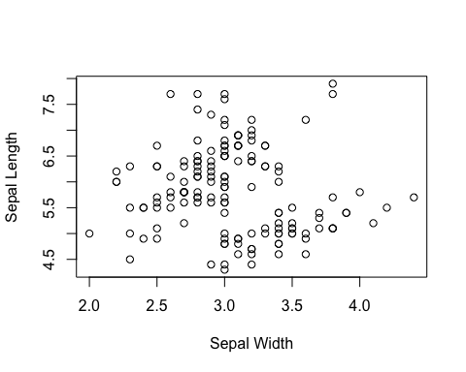

hist(iris$Sepal.Length, xlab = "Sepal Length")

